Creating your own Self-Care plan
- Assess your needs:
- Start by making a list of the different parts of your life and major activities that you engage in each day. Work, relationships, and family are some you might list
- Consider your stressors:
- Think about the aspects of these areas that cause stress, any barriers to self-care and consider some ways you might address stress/barriers
- Devise self-care strategies:
- Think about some activities or actions that will help you feel better in each of these areas of your life
- Plan for challenges:
- If you discover that you're neglecting a certain aspect of your life, create a plan for change
- Take small steps:
- You don't have to tackle everything all at once. Identify one small step you can take to begin caring for yourself better
- Schedule time to focus on your needs:
- Even when you feel like you don't have time to squeeze in one more thing, make self-care a priority. When you're caring for all aspects of yourself, you are able to operate more effectively and efficiently.

Assess your needs | Consider your stressors
Devise self-care strategies | What is your plan for any challenges that arise? How can you prioritise self-care?

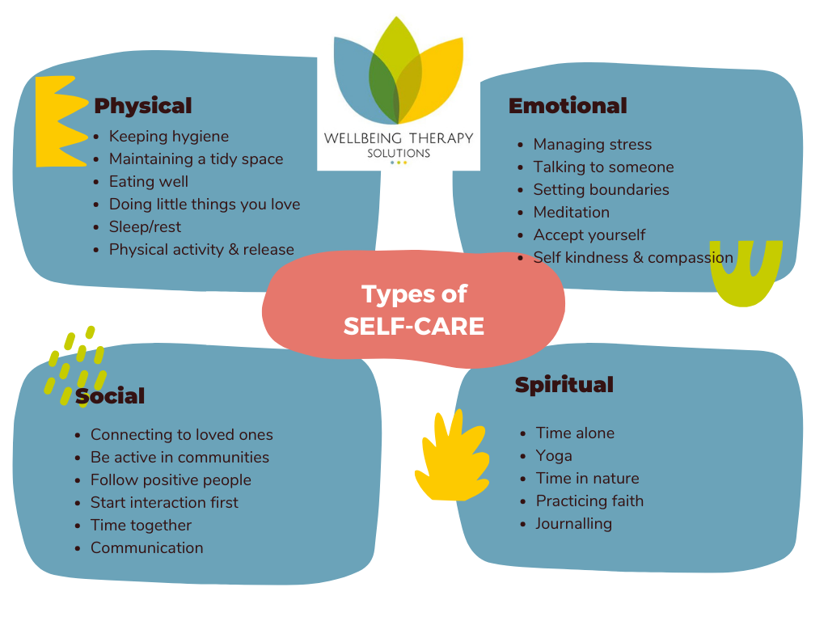
Write down the self-care activities and actions you want to undertake to address the four domains:
Physical | Emotional
Social | Spiritual

Do you have a mix of:
- Daily activities
- Weekly activities
- Monthly activities
- Quick in the moment practices
- Longer term gains
- Actions relevant to what is in your control
- Achieving a balance of activities that address your physical, social, emotional and spiritual needs

